The Higher School of Linguistics would like to encourage all those interested in Linguistics, Translation Studies and Language Teaching to:

- participate in the Translation and Language Teaching Workshop which will be held on 16th June 2015 (a day before the conference sessions proper);
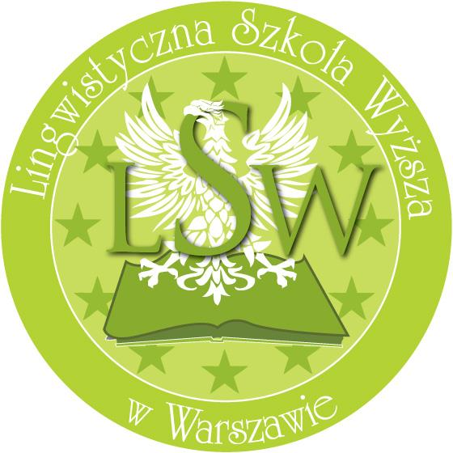
- contribute papers pertaining to major topics provided in the conference circular. (The format is 20 minutes for presentation plus 10 minutes question time);
- submit a poster summarizing research in the disciplines of translation studies or teaching methodology and practice;
- submit original research results in the fields of translation studies or teaching methodology in the form of ideatorium (3 minutes format)
- and/or submit an article to be published in the LSW Journal issued annually; (Editing requirements to be provided as part of conference materials or at the conference website). The Review Commission will evaluate the articles and final decision regarding their publication in the conference proceedings, based on specialists’ reviews, will be made respectively.

Abstract Submission:
Please include your Abstracts consisting of up to 2000 characters in the Conference Registration form provided.

The final decision regarding the acceptance of papers will be taken by 15 January 2014. Conference organizers restrict the right of moving papers/presentations to the Ideatorium section.

Presentations and papers are expected to be delivered in either Polish or English.

We would also like to invite everybody interested and involved in Language Teaching, Translation Theory and Practice to participate in our conference. The conference is addressed in particular to practising language teachers at all levels (including kindergarten teachers) and translators. Attendants who will not be giving presentations are encouraged to exchange ideas and opinions in debates and discussions both during conference sections, plenary sessions and informal conversations.

Conference fees:
- with a paper - covers conference materials, coffee breaks, lunches, conference dinner reception, DTP service, conference certificate: 600,00 PLN or 150 € per person
- with a paper - covers conference materials, coffee breaks, lunches, DTP service, conference certificate: 400,00 PLN or 100 € per person
- Non-speaking participants - covers conference materials, coffee breaks, lunches, conference dinner reception, DTP service, conference certificate: 400,00 PLN or 100 € per person
- Non-speaking participants - covers conference materials, coffee breaks, lunches, DTP service, conference certificate: 200,00 PLN or 50 € per person

Make payment of the conference fee by bank transfer to the following bank account No.

05 1440 1387 0000 0000 0895 7908

no later than 15 February 2015 - see www.konferencja.lingwistyka.edu.pl for the bank account number and other details. Please print your name and surname and the word KONFERENCJA on your payment slip.

Note that payments cannot be refunded. If you wish the invoice to be issued to the institution you are affiliated with, the payment needs to be made from the bank account of that institution. For payments made from a personal bank account, the invoice will be issued to the owner of the bank account.

Forms of payment:
- Polish currency bank account: 05 1440 1387 0000 0000 0895 7908
- With the following information added:
a. Full name of participant
b. For: Fundacja Nowy Świat
c. Conference fee [Dialogue of Languages and Cultures]

- Euro bank account: PL 31 1440 1299 0000 0000 1720 8284
Nordea Bank Polska S.A.; Swift: NDEAPLP2

- With the following information added:
a. Full name of participant
b. For: New World Foundation
address: Ogrodowa 46/48, 00-876 Warszawa
c. Conference fee [Dialogue of Languages and Cultures]

The conference is co-organized by “New World” Foundation (Ogrodowa 46/48, 00-876 Warsaw). Conference fee is to be paid to the conference account.

Send an e-mail to www.konferencja.lingwistyka.edu.pl with a proof of payment attached. Attendants who will not be giving presentations (non-speaking participants) are kindly requested to supply the following information in the content of the e-mail:
- name, title/position
- affiliation
- e-mail address

Information regarding the accomodation (paid directly in the hotels) at the special rates offered to conference participants will be provided in the registration form on the conference website.

